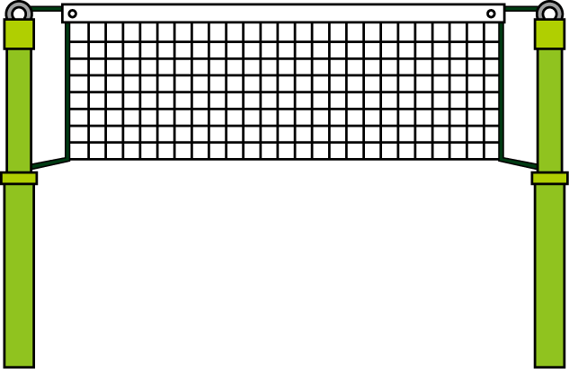

**Participant**

Last Name: ____________________________________________ First Name: ________________________________

CCCC Member: Yes No Date of Birth: ___________ Age: _________ Gender: M or F

Address: _____________________________________________ City: ________________________ Zip: __________

Phone Numbers: _______________________________________ __________________________________________

Email Address(s):_________________________________________________________________________________

* * * * * * * * * * * * * * * * * * * * * * * * * * * * * * * * * * * * * * * * * * * * * * * * * * * * * * * * * * * * * * * * * * *

Registration Information

In consideration of accepting my entry, I do hereby for myself, my heirs, executors, administrators and assigns, waive and release all claims, damages, which I may have or which may hereafter accrue to me against the Carroll County Community Center (CCCC), its sponsors, representatives or assigns for any and all damages which may be sustained and suffered by me

in connection with my association with or participation in the CCCC program. I attest I am physically fit and have full knowledge of the risks involved in the program. Participants and members involved in CCCC activities and classes give permission for use of their name, photograph, or other likeness of themselves, their oral or written statement; or other aspects of their personalities in whole or part for advertising or similar purposes. They give consent voluntarily and without expectation of any remuneration or reward and waive all rights to any such remuneration or reward.

SIGNATURE REQUIRED ***Participant/Guardian’s Signature (If Under 18):*** _______________________________________

***For Office Use Only***

Program Cost: $__________ Payment Type: ____cash ____check#_________ Staff Initials: ________